
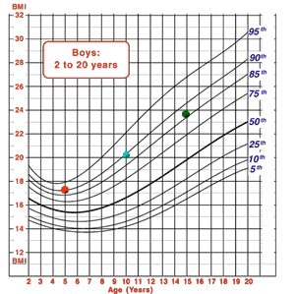
Certificate of Attendance

____________________
attended the workshop
Assessing Child Growth Using
Body Mass Index (BMI)-for-Age Growth Charts
Presented by:
Agency
Location
Date
Date
Trainer Name
Child Health and Disability Prevention Program
BMI-Certificate (8/10)

